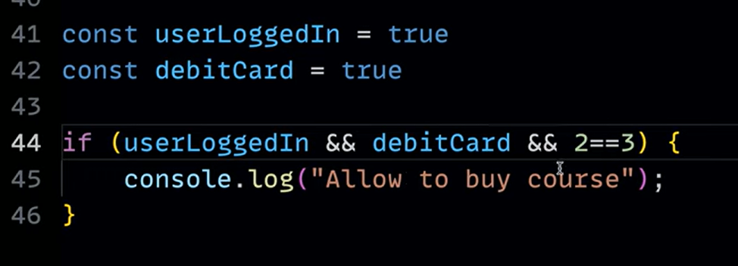

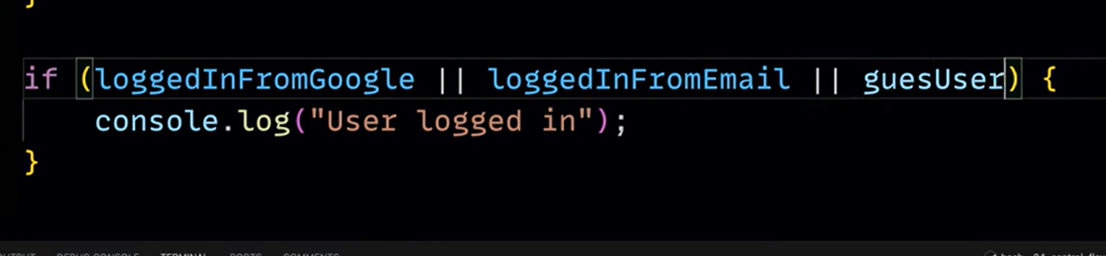

What is conditional rendering?

**Conditional rendering** is a concept in programming, particularly in **web development**, where content or UI elements are displayed (or hidden) based on certain conditions or criteria. It allows developers to dynamically control what gets shown in the user interface depending on the application's state, user input, or other factors.

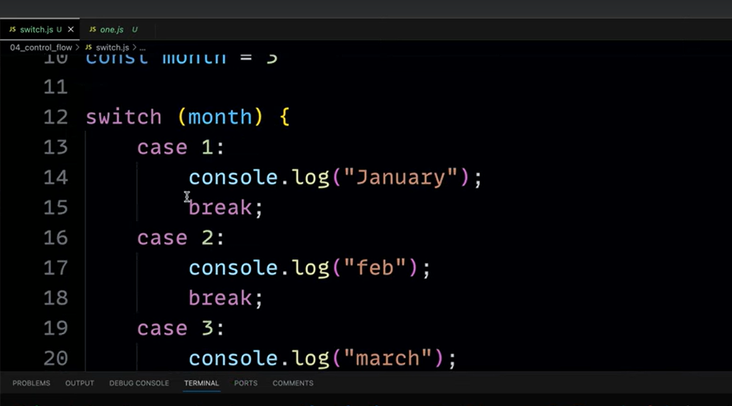

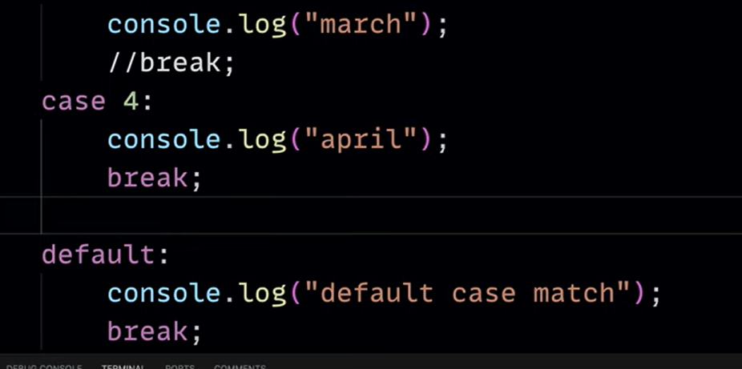

In switch if any 1 of the cases like 3 is matched then the cases below it are not chked and all are executed except for default…this but don’t happens in new langs like swift

